**Provisioning Jig v3 Assembly Guide**

Project by Jesse Jabez Arendse  
Project for UCT EEE Department - Robyn Verrinder & Justin Pead

**Assembly Considerations:**

* Optional STLink Cap to further prevent accidental shorts
* Enclosure is self-locking
* 2x 10mm spacers are needed between the PCBs
* 2x M2.5 Bolts & Nuts should be used to secure the PCBs, or M2.5 Rods can be used to connect the Jig and the enclosure for table mounting

**Assembly Guidelines:**

Solder POGO pins and headers ONLY for each circled throughhole

Place M2.5 Bolts through the PCB holes, POGO Support 3D print holes while ensuring each pin goes through their specific hole, and RPI. Secure with Nuts

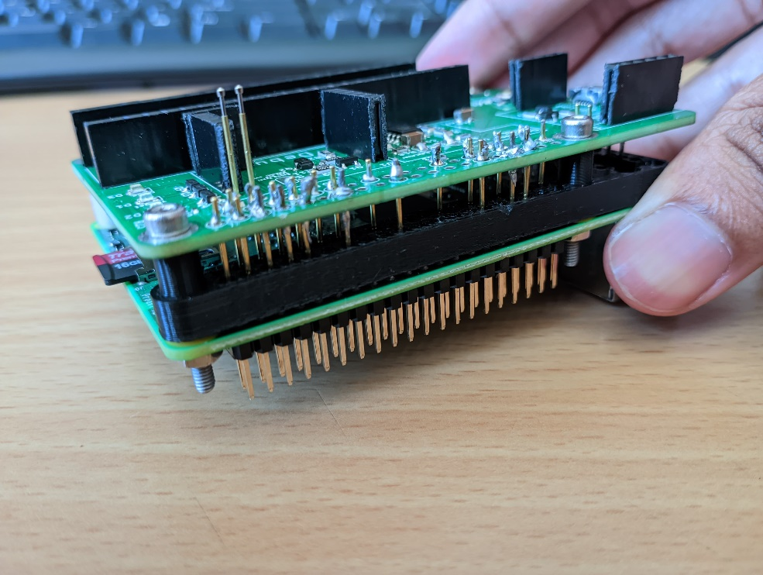

The enclosure base has slots for the excess bolt shafts to pass through, which also aligns and secures the PCBs.

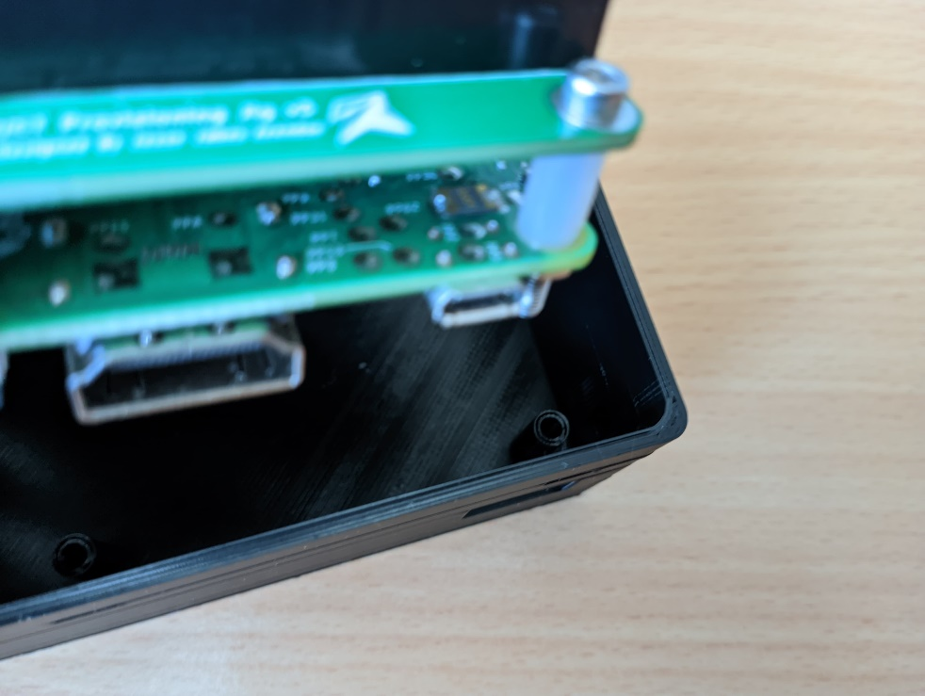

Complete the Jig with the lid, making sure the headers pass through the gaps of the lid and the protruding bits lock the enclosure. It’s quite tight and needs some force to assemble and dissemble. Plug in an already programmed debugger into the STLink slot to complete the Provisioning Jig Assembly.

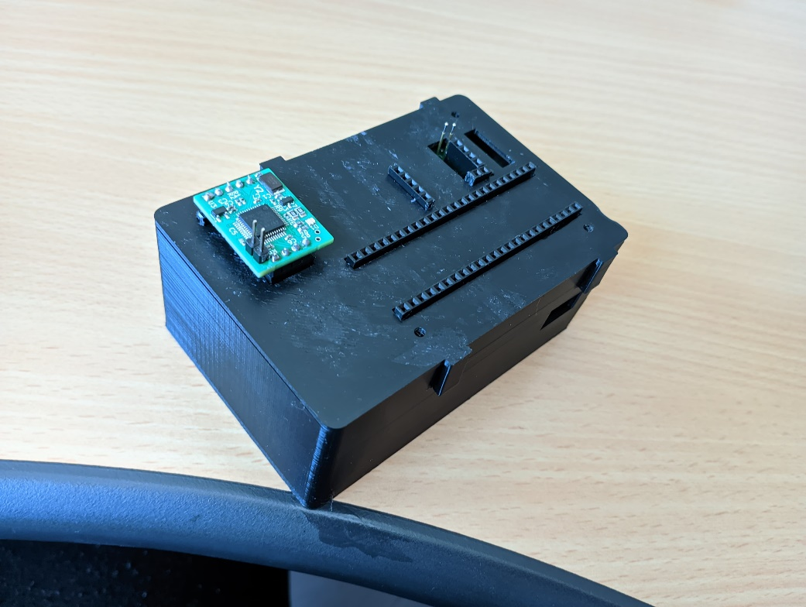

An assembly video can be found on the gitrepo as well.